Grade 7 Accelerated · Unit 6 · Lesson 5  Distance on the Coordinate Plane  Question Bank - Additional 6.05 ANSWER KEY | Name  Date  Period

Show your work. Circle your final answer.
For questions 1 through 7, find the distance between the two points. Round to the nearest tenth when it is not a whole number.
1. 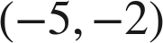 and 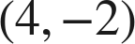
9 units
Same y.

2. 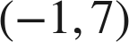 and 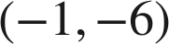
13 units
Same x.

3. 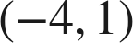 and 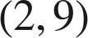
10 units
Across 6, up 8.

4. 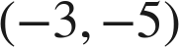 and 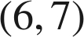
15 units
Across 9, up 12.

5. 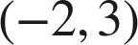 and
√61 ≈ 7.8 units
Across 6, down 5.

6.  and 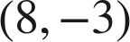
√73 ≈ 8.5 units
Legs 8 and 3.

7. 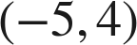 and 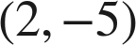
√130 ≈ 11.4 units
Across 7, down 9.

Choose one.
8. What is the distance between 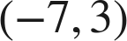 and 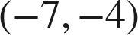?
○ A. 8
○ B. −7
○ C. 1
● D. 7
D
Same x: 3 − (−4) = 7.

9. Which gives the distance between 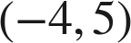 and 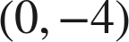?
○ A. 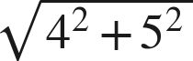
● B. 
○ C. 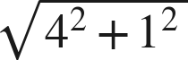
○ D. 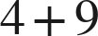
B
Across 4, down 9: √97.

